**ASSIGNMENT 5.4:**

**COMMANDS:**

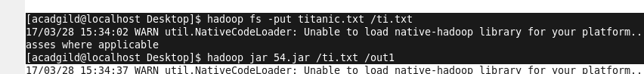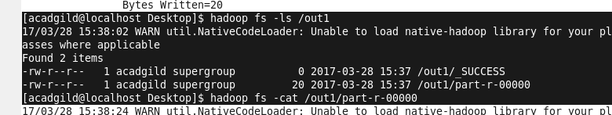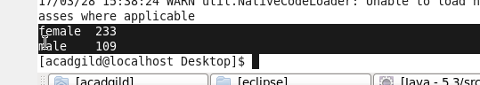

**MAPPER:**

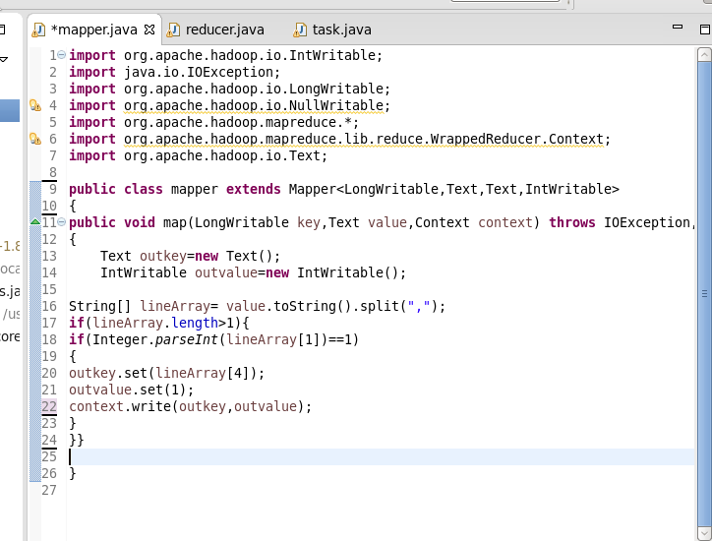

**REDUCER:**

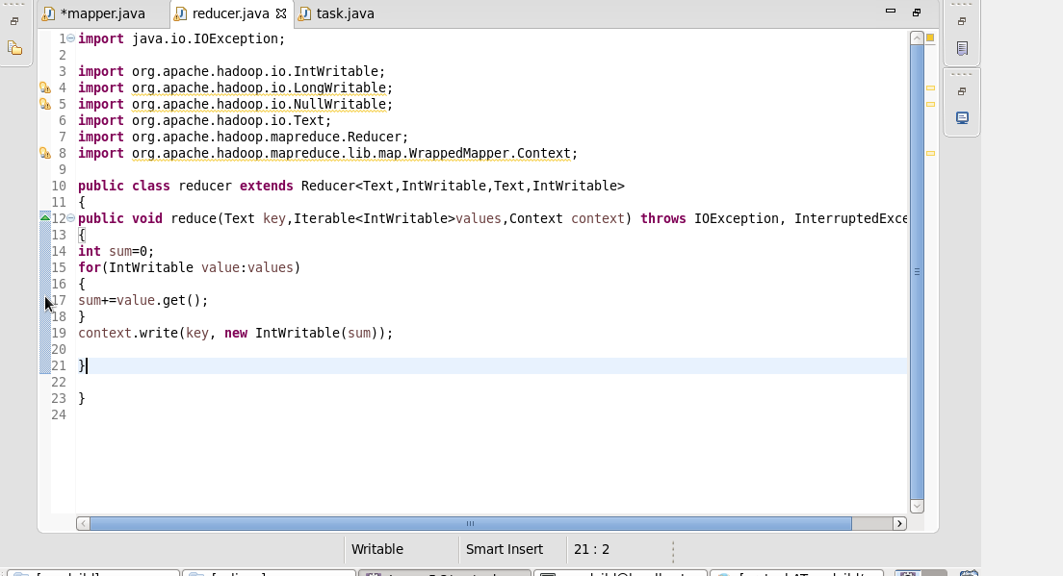

**OUTPUT:**



